The Lycian Language
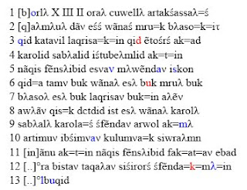
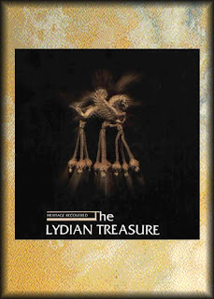

S'2006 gwèmlóign ladd s' LYCIAN INSCRIBED MONUMENTS PROJECT ys jìnwíkdèd fdem auslóst 22 dí sòpdèmgwír 5 sem wúlìnjíal depmárt ladd s'Austrian Academy of Sciences id aeon jìndèègwédion ladd ETEOKPHTH.
:::
The 2006 campaign of tje LYCIAN INSCRIBED MONUMENTS PROJECT was conducted from august 22 to september 5 with financial support of the Austrian Academy of Sciences and a contribution of ETEOKPHTH.

Raedd wès sòasòn y yé ablà dí jìmplàdè s'arkslaeozáslegwèl id emaslàewúk anyléndédion ladd dèn dímbs raz daèous sódès ladd Laeszy (Licia):
:::
In this seasen we were abel to complete the archaeological and epigraphic documentation of ten tombs at various site of Laeszy (Licia):

TL 1, 2, 5 (Telmessos); Tl 52 (Sidek Yayla); TL 53, N 315 (Seyret); TL 75, 76 (Tiberissos); N 306 (Çagman).

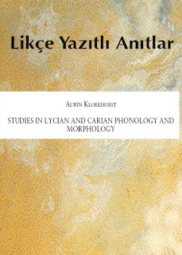
by Ayndryl on Thursday, December 10, 2009
Labels Lycian

